Phase 8: Implement Client Script & UI Policy (Incident)
Project Demonstration Phase
1. Introduction
The Project Demonstration Phase explains the practical working of the Implement Client Script & UI Policy (Incident) project in the ServiceNow platform. This phase demonstrates how the configured UI Policy, UI Policy Actions, and Client Scripts operate on Incident forms and lists.
The demonstration presents the project workflow step by step, showing how field behavior changes according to Impact, how Urgency is automatically updated, how required information is validated, and how direct State changes through list editing are restricted.
2. Objectives of Demonstration
The main objectives of the demonstration are:
- To demonstrate the High Impact Control UI Policy on the Incident table.
- To show how Assignment Group becomes mandatory when Impact is High.
- To demonstrate the read-only behavior of the Urgency field.
- To show automatic Urgency updates using an onChange Client Script.
- To demonstrate submission validation using an onSubmit Client Script.
- To show how an onCellEdit Client Script blocks State changes from the list.
- To verify that State can still be updated through the Incident form.
3. Demonstration Environment
Component | Details
Platform | ServiceNow
Application | Incident Management
Table | Incident
UI Policy | High Impact Control
UI Policy Actions | Assignment Group, Urgency
Client Scripts | onChange, onSubmit, onCellEdit
Demonstration method | Live practical demonstration
4. Demonstration of UI Policy
Demo 1
High Impact Control
Procedure:
- Log in to the ServiceNow instance.
- Navigate to Incident → Create New.
- Locate the Impact field on the Incident form.
- Select High as the Impact value.
- Observe the Assignment Group field.
Demonstration result:
- The High Impact Control UI Policy is triggered.
- Assignment Group becomes mandatory.
- The policy applies its configured field behavior while Impact is High.
What to explain during the demonstration
“The UI Policy checks the Impact field. When Impact is High, the policy makes Assignment Group mandatory. The Reverse if false option allows the policy changes to be reversed when the condition is no longer satisfied.”
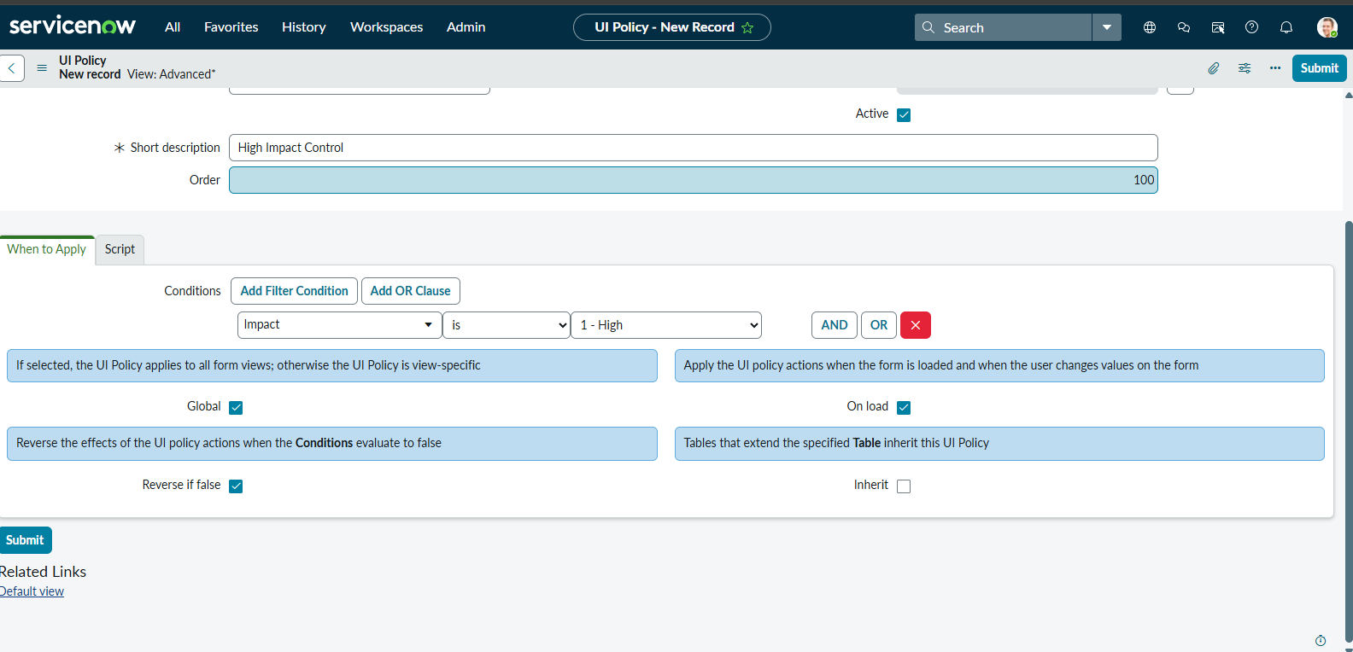
5. Demonstration of Urgency UI Policy Action
Demo 2
Urgency Read-only Behavior
Procedure:
- Continue with the Incident form.
- Set Impact to High.
- Locate the Urgency field.
- Attempt to change the Urgency value manually.
Demonstration result:
- Urgency remains visible.
- Urgency becomes read-only while Impact is High.
- When Impact changes away from High, the UI Policy reverses the read-only setting.
What to explain:
“The Urgency UI Policy Action controls whether the field can be edited. When the High Impact condition is true, the user can view Urgency but cannot manually change it.”
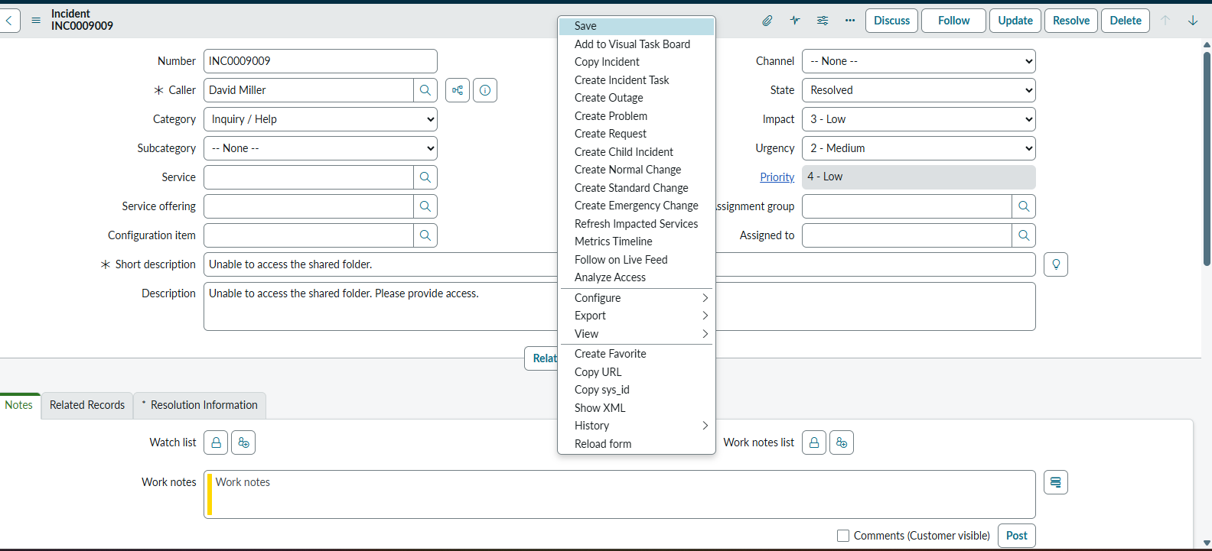
6. Demonstration of onChange Client Script
Demo 3
Automatic Urgency Update
Procedure:
- Open a new Incident form.
- Change Impact to High.
- Observe the Urgency field.
- Check the informational message displayed on the form.
Demonstration result:
- The onChange Client Script detects the Impact change.
- Urgency is set to High.
- The form displays the message: “Urgency set to High for High impact incident.”
What to explain:
“The onChange Client Script runs when the Impact field changes. If the new value is High, the script sets Urgency to High automatically and displays an informational message.”
7. Demonstration of onSubmit Client Script
Demo 4
Prevent Saving When Assigned To Is Missing
Procedure:
- Open a new Incident form.
- Set Impact to High.
- Leave the Assigned To field empty.
- Fill in any other required fields.
- Click Submit.
- Observe the validation message.
Demonstration result:
- The onSubmit Client Script checks Impact and Assigned To.
- Since Impact is High and Assigned To is empty, submission is blocked.
- An error message appears beside Assigned To.

Important point to explain
“The UI Policy makes Assignment Group mandatory, while the onSubmit Client Script checks Assigned To. These are separate rules, so both fields and their validation behavior should be demonstrated.”
8. Demonstration of Successful Incident Submission
Demo 5
Save with Required Information
Procedure:
- On the Incident form, keep Impact set to High.
- Select a user in the Assigned To field.
- Ensure Assignment Group is also filled.
- Complete any other required fields.
- Click Submit.
Demonstration result:
- The onSubmit validation allows submission because Assigned To is provided.
- The Incident should save if all other platform requirements are satisfied.
- The record can be opened to confirm the saved information.
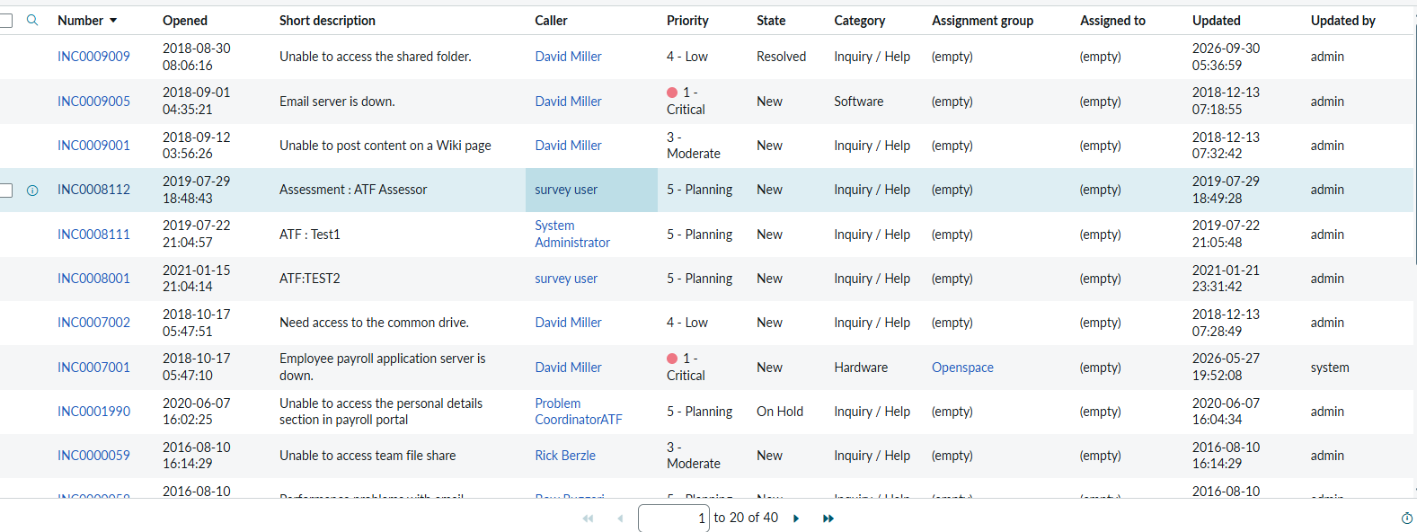
9. Demonstration of Reverse Condition
Demo 6
Change Impact from High to Medium
Procedure:
- Open an Incident where Impact is High.
- Change Impact to Medium.
- Observe Assignment Group and Urgency.
- Attempt to edit Urgency.
Demonstration result:
- Assignment Group is no longer mandatory because of this UI Policy.
- Urgency becomes editable again.
- The UI Policy's Reverse if false behavior is demonstrated.
What to explain:
“When the condition becomes false, the UI Policy reverses its field actions. This allows the form to return to its normal behavior for Incidents that are not High Impact.”
10. Demonstration of onCellEdit Client Script
Demo 7
Block State Changes Through List Editing
Procedure:
- Navigate to Incident → All.
- Locate an Incident record.
- Double-click the State field in the list.
- Attempt to change the State value.
- Observe the alert message.
Demonstration result:
- The onCellEdit Client Script runs for the State list edit.
- An alert appears: “State cannot be updated using list editing. Please open the Incident.”
- The callback rejects the change, so the list edit should not be saved.
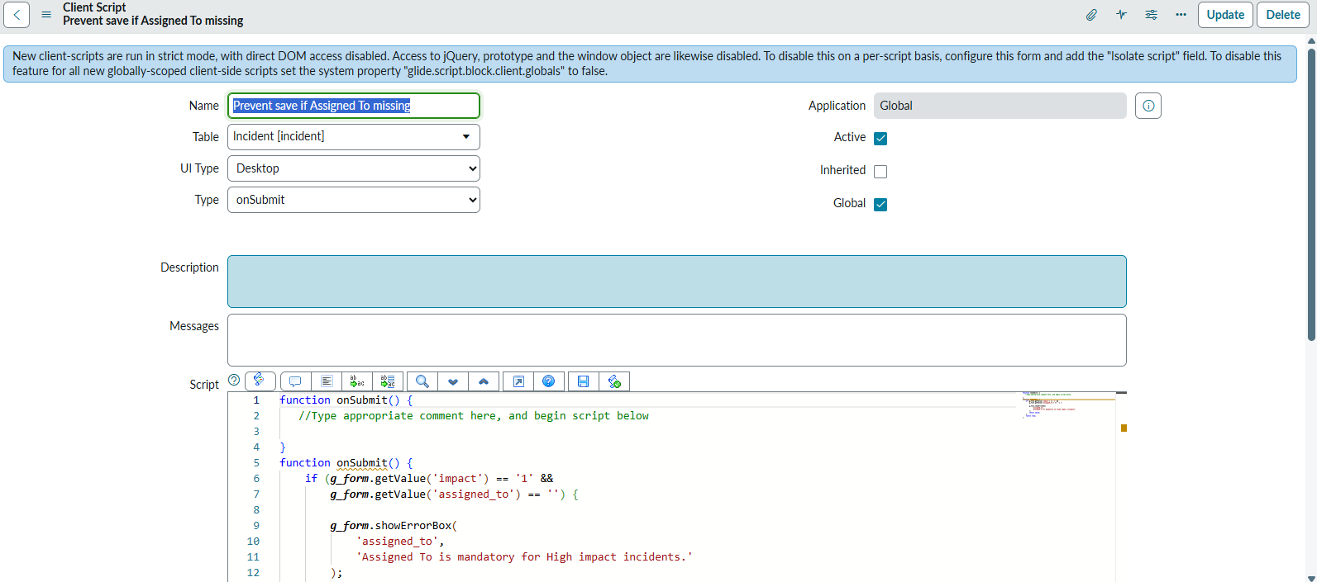
11. Demonstration of Form-based State Update
Demo 8
Update State Through the Incident Form
Procedure:
- Open an existing Incident record from the list.
- Locate the State field on the form.
- Change State to another available value.
- Click Update.
- Reopen or refresh the record to verify the saved value.
Demonstration result:
- The State field can be updated through the Incident form, subject to other applicable rules.
- The onCellEdit restriction does not block this form-based update.
- The saved record reflects the updated State.
12. Demonstration Summary
Demo | Feature | Demonstrated behavior
1 | UI Policy | Assignment Group becomes mandatory for High Impact
2 | UI Policy Action | Urgency becomes read-only
3 | onChange Script | Urgency automatically becomes High
4 | onSubmit Script | Submission blocked if Assigned To is empty
5 | Successful submission | Incident saves with required information
6 | Reverse condition | Policy changes reverse when Impact is Medium
7 | onCellEdit Script | State list editing is blocked
8 | Form-based update | State can be updated through the form
13. Screenshots and Evidence
The following screenshots can be included in the project report or presentation to document the live demonstration:
- UI Policy configuration: High Impact Control policy with its condition and Reverse if false setting.
- UI Policy Actions: Assignment Group mandatory and Urgency read-only configurations.
- onChange Client Script: Script configuration for automatic Urgency assignment.
- onSubmit Client Script: Script configuration for Assigned To validation.
- onCellEdit Client Script: Script configuration for blocking State list editing.
- High Impact form: Incident form showing the conditional field behavior.
- Validation message: Form displaying the error when Assigned To is missing.
- List edit alert: Alert shown when attempting to change State from the list.
- Successful update: Incident form showing a saved State change.
Use screenshots captured from your own ServiceNow instance so the evidence reflects the actual configuration and test results.
14. Conclusion
The Project Demonstration Phase presents the practical operation of the Implement Client Script & UI Policy (Incident) project. It demonstrates how UI Policies control conditional field behavior and how Client Scripts automate field updates, validate form submission, and restrict direct list editing.
The demonstration also shows the difference between list-based and form-based State updates and verifies the behavior of the Reverse if false setting. Together, these demonstrations explain how the configured controls support accurate, consistent, and structured Incident data entry in ServiceNow.

